National Academy of Science and Technology

**DHANGADHI ENGINEERING COLLEGE**

Affiliated to Pokhara University

Uttar Behani-04, Dhangadhi, Kailali, Province 07



A Project Report

On

**“RESULT MANAGEMENT SYSTEM”**

Submitted in partial fulfilment for the requirements for the Award of Degree of

BACHELOR OF ENGINEERING

IN

COMPUTER ENGINEERING

SUBMITTED BY

Aasha Bhatta (18070119)

Gyanu Awasthi (18070129)

Kalak Kumar Malla (18070136)

Sushil Kunwar (18070162)

UNDER THE GUIDANCE OF

Er. Harendra Bikram shah

Lecturer

Dept. Of Computer Engineering, DEC

SUBMITTED TO

Department of Computer Engineering,

Dhangadhi Engineering College

**ACKNOWLEDGEMENT**

Any achievement, be it scholastic or otherwise does not depend solely on the individual efforts but on the guidance, encouragement and cooperation of intellectuals, elders and friends. We would like to take this opportunity to thank them all.

First of all, we would like to thank the DEC for providing us with all the necessary requirements for our project.

We are grateful to acknowledge the guidance and encouragement that has been given to us by **Er. Harendra Bikram Shah, Lecturer**, Department of Computer Engineering, DEC, Dhangadhi, who has rendered a valuable assistance and guidance.

We also extend our thanks to the entire faculty of the **Department of Computer Engineering,** DEC, Dhangadhi, who have encouraged us throughout the course of the project.

Last, but not the least, we would like to thank our family and friends for their inputs to improve the project.

**Aasha Bhatta (18070119)**

**Gyanu Awasthi (18070129)**

**Kalak Kumar Malla (18070136)**

**Sushil Kunwar (18070162)**

**DECLARATION**

We, Aasha Bhatta, Gyanu Awasthi, Kalak Kumar Malla, Sushil Kunwar, students of Computer Engineering, semester 4th, Dhangadhi Engineering College affiliated to Pokhara University, hereby declare that the work undertaken in this minor project entitled “**Result Management System**” is the outcome of our own effort and is correct to the best of our knowledge. This work has been accomplished by obeying the engineering ethics; and it contains neither materials published earlier or written by another person/people nor materials which has been accepted for the award of any other degree or diploma of the university or other institution, except where due acknowledgement has been made in the document.

|  |  |
| --- | --- |
| …………………………… | …………………………….. |
| Aasha Bhatta | Gyanu Awasthi |
| Date: | Date: |
| ……………………………… | …………………………….,.. |
| Kalak Kumar Malla | Sushil Kunwar |
| Date: | Date: |

**CERTIFICATE**

This is to certify that the project report entitled 'RESULT MANAGEMENT SYSTEM' is a report of the work carried out by our group under the guidance and supervision of Er. Harendra Bikram Shah for the partial fulfilment of degree of bachelor of Computer Engineering by Pokhara University.



To the best of our knowledge and belief, this work embodies the work of candidates themselves, has duly been completed, fulfils the requirement of the ordinance relating to the Bachelor degree of the university and is up to the standard in respect of content, presentation and language for being referred to the examiner.

|  |  |
| --- | --- |
| **Er. Harendra Bikram Shah** | **Er. Ravi Khadka** |
| Lecturer, BE Comp. Department | HOD, BE Comp. Department |
| NAST | NAST |
| Dhangadhi, Kailali | Dhangadhi, Kailali |
| ………… | ………… |
| **Signature** | **Signature** |

………………………...

**Signature of External**

**ABSTRACT**

The purpose of the project entitled as " **RESULT MANAGEMENT SYSTEM** " is to provide the examination result to the student in the simple way. This project is useful for students and institution for getting the result in simple manner.

The system privileges that are provided to the student are to read and execute his/her result by providing user name and password for secure login and in case of new student registration is available. The whole result analyzer will be under the control of administrator and the admin has full right to read, write and execute the result. Admin gives the privileges to the teacher and student and the guest user to access the result.

**TABLE OF CONTENT**

**Sn. Contents Page No**

ACKNOWLEDGEMENT………………………………………………………….I

DECLARATION…………………………………………………………………..II

CERTIFICATION…………………………………………………………………III

ABSTRACT……………………………………………………………………….IV

LIST OF FIGURES……………………………………………………………….VI

LIST OF TABLES……………………………………………………………….VI

1. INTRODUCTION
   1. Overview of Result Management System………………………………………...1
   2. Project Objectives…………………………………………………………………1
   3. Project Background…………………………………………………….................2
2. SYSTEM ANALYSIS
   1. System Requirements/Specifications
      1. Software Requirements……………………………………………………2
      2. Hardware Requirements…………………………………………………...2
   2. Existing System…………………………………………………………………...3
   3. Problems with existing system…………………………………………................3
   4. Proposed system ……………………………………………………….................3
3. SYSTEM DESIGN
   1. ER Diagram ……………………………………………………………………….4
4. SYSTEM IMPLEMENTATION
   1. Modules…………………………………………………………………………...5
   2. Screenshots………………………………………………………………………..5
5. FEASIBILITY STUDY
   1. Time Feasibility…………………………………………………………………...9
   2. Economic Feasibility…………………………………………………………….10
6. ADVANTAGES &LIMITATIONS
   1. Advantages………………………………………………………………………10
   2. Limitations……………………………………………………………………….10

7. FUTURE WORK…………………………………………………………………..10

CONCLUSION…………………………………………………………………….11

REFERENCES……………………………………………………………………..12

**LIST OF FIGURES**

**Fig. No. Contents**

1 ER diagram for result management system

2 Main form

3 Login form

4 Registration form

5 Form for recording data of new student

6 Result displaying

7 Result obtained

8 Result report

9 Result printing

**LIST OF TABLES**

**Table No. Contents**

1 Software requirements

2 Hardware requirements

3 Time Schedule

1. **INTRODUCTION**

**1.1Overview of Result Management System**

The main objective of developing this project is to automate students result management. This application will greatly simplify and speed up the result preparation and management process. This is a computerized examinations result management system for tertiary student's examination records. The main aim of the project is to provide the examination result to the student in a simple and accurate way. The application will manage the information about various students in various subject in different semester. The manual method of student’s academic result processing was found to be tedious, especially when carried out for a large number of students, this makes the entire process time consuming and error prone.

This project is useful for students and institutions for getting the results in simple manner. The system designed is meant to register students as soon as they have paid their departmental registration and only then they will be able to view their results. The software will also generate summary report regarding student’s information, semester wise marks list and performance report. The whole result analyzer will be under the control of administration and the admin as the full privileges to read, write and execute the result. The project Result management system presents a single platform that will be used to manage the processing of all examinations records within the institution.

This application is reduced as much as possible to avoid errors while entering the data. It also provides error message while entering invalid data. No formal knowledge is needed for the users to use this system. Thus, by this all it proves it is user friendly. Result management system, as described above can lead to error free, secure, reliable, and fast result. Thus, it will help the institution in better utilization if resources.

* 1. **Project objectives**

The objectives of the project are as follows:

* The main aim of the project is to design the software that manages the examination result of the student in simple and accurate way.
* To reduce the duplication of the results.
* To provide the security for storing the data of results properly.
* To reduce time taken while recording the result of the student in the database of the software.
* To reduce the loss of data.
* To provide the error detection and correction of errors.
* This application will greatly simplify and speed up the result preparation and management process.
* Provides the searching facilities based on various factors such as result, student, course, exam
* Shows the information and description of the result and student.

Editing, adding, and updating of records is improved which results in proper resource management of result data.

* 1. **Project background**

The software we have designed is used to computerize the student’s data for result processing purpose. The purpose of the project entitled as “Result Management System” is to computerize the student's result records in the simple and efficient way. The main function the system is to register the students and record the marks and all the required details in order to deliver the result of the student. The system requires input of student’s information data, result record, fee structures, and subject register. After these data are entered in the system, it gets processed and result of the student is obtained with their total percentage gained or GPA. Here, only the students that is registered can see his/her result. The one who has not been registered cannot get the result as his/her data is not stored in the database.

It is a computerized automated system which is less time consuming and less prone as compared to traditional file processing system. The system we have designed is developed using C# language which manages the student's result in simple and accurate manner.

1. **SYSTEM ANALYSIS**

**2.1. System requirements/Specifications**

**2.1.1 Software Requirements:**

|  |  |
| --- | --- |
| **Operating System** | Windows 10 |
| **User Interface** | C# |
| **Database** | SQL Server |
| **Documentation Tool** | Ms Office |

Table1: software requirements

**2.1.2 Hardware Requirements:**

|  |  |
| --- | --- |
| **Processor** | Intel Core(i5) Processor |
| **Hard Disk** | Minimum 8 GB |
| **RAM** | Minimum 4 GB |

Table2: hardware requirements

* 1. **Existing System**

In the manual student result processing system, all the database commands have to be typed by the user. This procedure is very time consuming, and is limited to a single system

If someone wants to get information about a particular subject score, student's performance or any other information, they have to contact the administrator handling the system.The existing system was unable to the maintain and store the consistent data due to the duplication of data while recording the information so it is not a good approach to keep the records safe and secure.

**2.3. Problems with Existing System**

The traditional way of recording the student's information in the form of files, consisting of student's name, address, marks, obtained in a student's recording files is known as existing system. In the existing system the exams are done only manually but in proposed system, we have to computerize the exams using this application.

As every system has some errors and limitations, the existing system of result management system has also some problems and we have enlisted those problems as:

* Lack of immediate storage of results of the students.
* Loss of data when the files have been carried out from one table to another.
* There was no computerized system of result management earlier, so there was difficulty in recording the students result.
* More time consuming during recording the students result.
* Duplication of results.
* Insecurity of results.
* More Manpower.
* Lack of security of data.
* Needs manual calculations.

**2.4. Proposed System**

As the system is computerized and automated, the recording of the student will be accurate. Everything related to student's information is stored in the database which will make the students to access and see the result easily. Database in the system will automatically update the student's data every time when the data is recorded or registered. It provides high level of security and there is no risk of data mismanagement. The overall result processing system is easier, flexible, and requires less time.

The aim of proposed system is to develop the system of improved facilities. The proposed system can overcome all the limitations of the existing system. The system provides proper security and reduces the manual work.

* Security of data.
* Ensure data accuracy.
* Minimize the manual work.
* Less time needed for the processing.
* Greater efficiency.
* Better service.
* User Friendly and interactive.

1. **SYSTEM DESIGN**

**3.1 ER Diagram**

exam

Login

Student

User

can

takes

1

1

* 1

gives

resultt

1

m

m

1

m

Fig1: ER diagram for result management system

1. **SYSTEM IMPLEMENTATION**
   1. **Modules**

As per the requirement of the educational institution i.e. schools/colleges, we analyzed that it requires some of modules that are as follows.

* Login Module: This is very prior in context to security view of the system as the student that is registered only can has login access.
* Data Entry Module: Here, all the students who want to create their account should register themselves.
* Result Reports Module: This module is only for the processing of the student’s result including their GPA or percentage show the pass/fail options.
* Fee Management Module: The student should have cleared his/her fee specified by the institution for getting the result so, this module shows the fee payment condition of the students. It gives information about all the academic activities payment such as total amount paid, admission fee, etc.
* Subject Registration Module: This module informs about the subject that are registered by the student before appearing the examinations.
  1. **Screenshots**

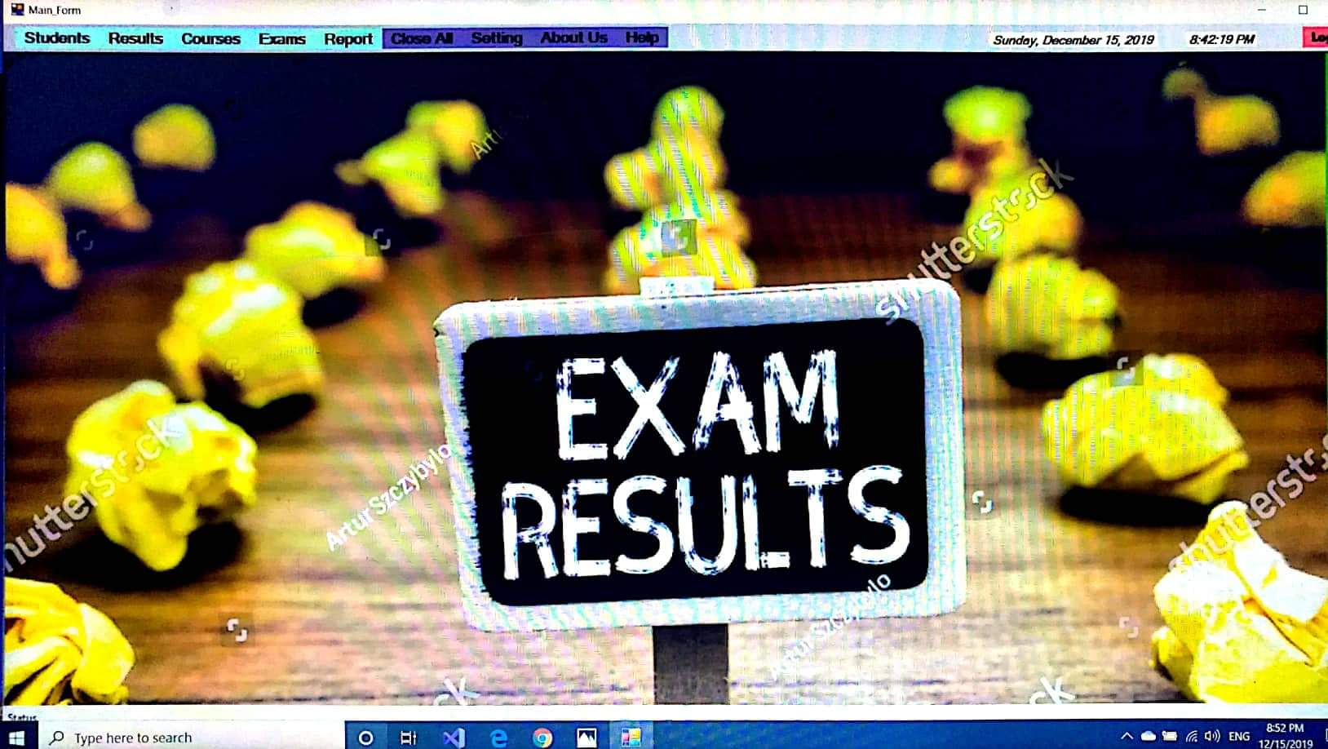

Fig2. Main form

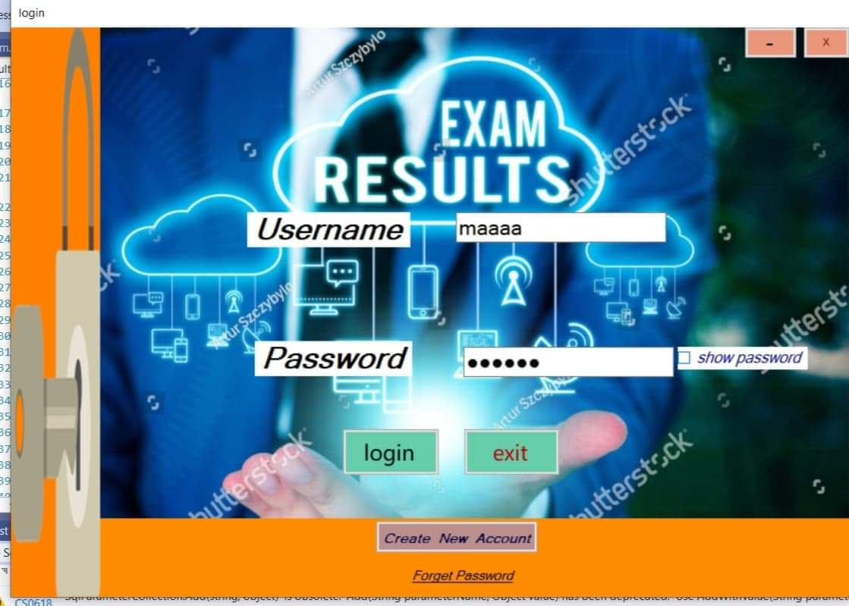

Fig3. Login form

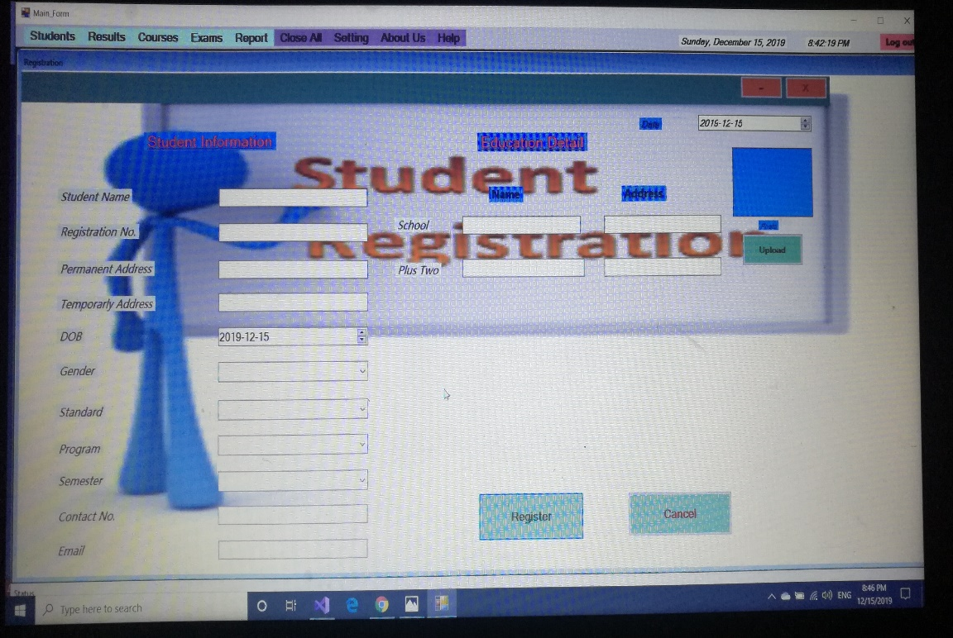

Fig4. Registration form

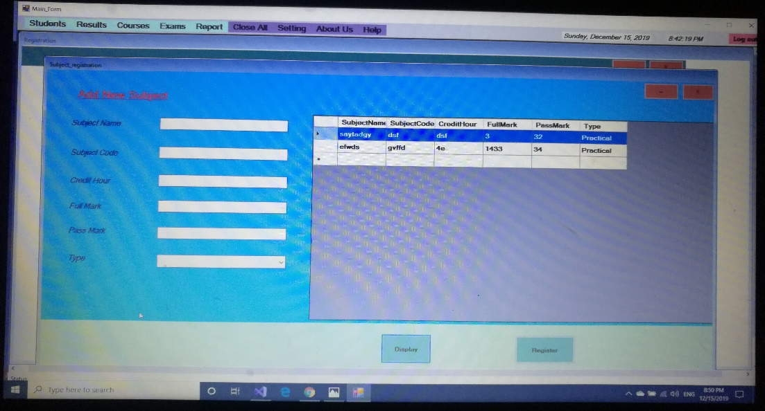

Fig5. Form for recording data of new student

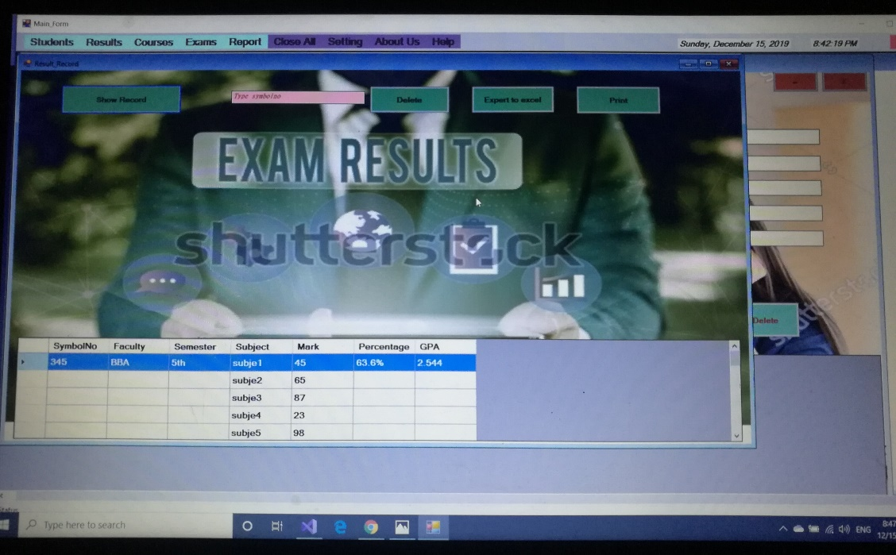

Fig6.Result displaying

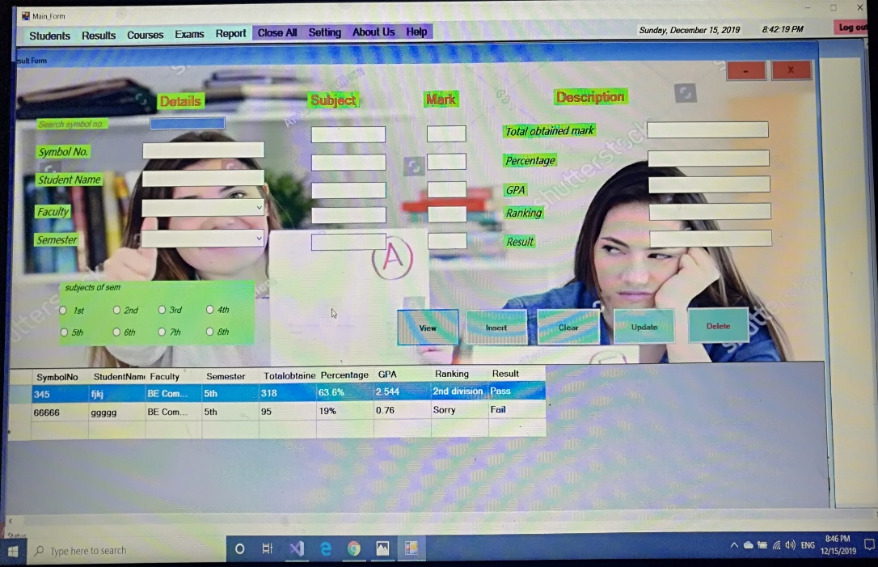

Fig7.Result obtained

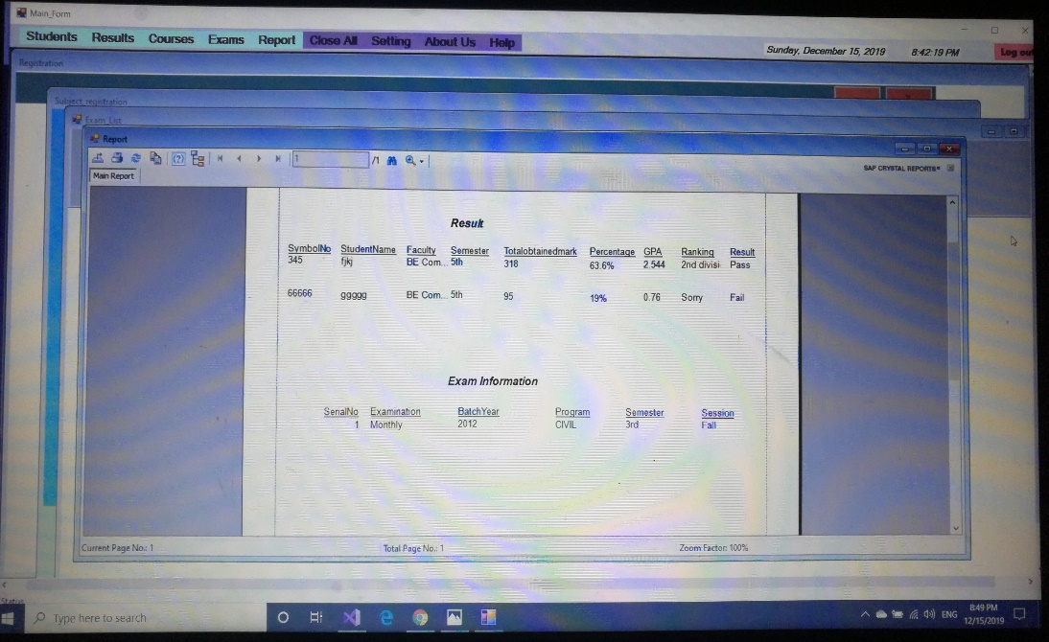

Fig8.Result report

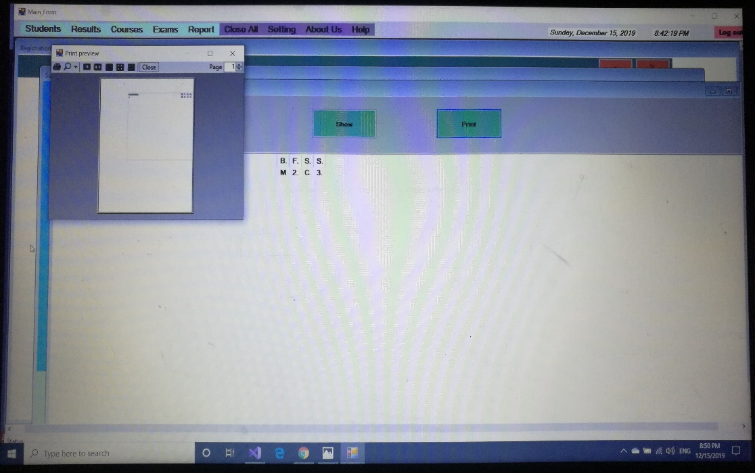

Fig9. Printing of result

1. **FEASIBILITY STUDY**
   1. **Time Feasibility**

For the analysis and preparation of this project, it took a week. The requirements for the project are easily available and the modules that, we have included can be coded in less time according tour working schedule for its completion.

|  |  |  |  |  |  |  |  |  |  |  |  |  |
| --- | --- | --- | --- | --- | --- | --- | --- | --- | --- | --- | --- | --- |
| Phases | W1 | W2 | W3 | W4 | W5 | W6 | W7 | W8 | W9 | W  10 | W  11 | W  12 |
| Problem Identification |  |  |  |  |  |  |  |  |  |  |  |  |
| Problem Analysis |  |  |  |  |  |  |  |  |  |  |  |  |
| Designing |  |  |  |  |  |  |  |  |  |  |  |  |
| Coding |  |  |  |  |  |  |  |  |  |  |  |  |
| Testing |  |  |  |  |  |  |  |  |  |  |  |  |
| Maintenance |  |  |  |  |  |  |  |  |  |  |  |  |
| Documentation |  |  |  |  |  |  |  |  |  |  |  |  |

Table3: time schedule of project

**5.2. Economic feasibility**

Economic feasibility study here, involves a cost investment as well as a cost benefit analysis upon the project that have been developed.

The economic feasibility is determined by:

* Estimating the project cost: The project developed is not more costly but it is around three to four thousand including all the charges like hardware, software, internet for researches etc. This is the rough estimation of the cost that is invested while working upon the project.
* Estimating the operation and management cost.

1. **ADVANTAGES & LIMITATIONS**
   1. **Advantages**

* Improve the result management system by computerizing.
* Simple and easy to use.
* Fully customizable.
* Highly secure and reliable.
* Less error prone.
* Dynamic reports.
* Use of RDBMS to wipe out the problem of data redundancy.
* Request for re-evaluation.
* Delivers the result to the student very fast.
  1. **Limitations**
* The system is prone to hacking.
* Extensive use of modules and the features make it difficult for a user to utilize the application.
* Unregistered students cannot access their results.

1. **FUTURE WORK**

The future work of this project is mainly based on the development of the following features which can be easily incorporated in the existing algorithm that has been purposed by us.

* We will be working on this project to make it accessible online.
* We will make accessible to the student to download the report of the result in the form of pdf.

**Conclusion**

The designed student management system is a very effective and efficient GUI based component. This software is well tested; it works properly to meet the user requirements as described in the project. Currently the system is window based giving all the required students result details. It has various future enhancement such as result report downloading, result printing, etc. can be incorporated in the system.

The main focus of our system is to reduce the manual work by computerizing them. It is very easy to use as we have provided the easy methods to edit, insert and remove the data from the system.

This system is developed using .NET framework and SQL Server which is considered more reliable and able to display the required output with less complexion. Hence, it reduces the human stress and manual work as being the computerized automated system. So, it is hoped that the system we have designed will be used greatly in near future rather this can be altered/modified to meet the requirement of the institution in upcoming future.

REFERENCES

1. <https://visualstudio.microsoft.com/>
2. <https://www.wikipedia.org/>
3. <https://www.ieee.org/>
4. <https://www.educative.io/>